assessing attachment in adults

from blog at www.stressedtozest.com posted on 18/10/09

I'm a doctor and psychotherapist who's interested in using attachment ideas to improve how helpful I can be for clients. Awareness of attachment issues informs therapy, it doesn't dictate it. An obvious question is whether it's sometimes worth assessing attachment in a "formal" way. I'm no expert in this area. I'm an "informed amateur" and, after reading and exploring a good deal around the subject, my impression is that it can be pretty useful at times to assess attachment. The Wikipedia article on Attachment meas-ures provides an excellent overview of the field while, for much more in depth information, the two attach-ment books and the various websites that I've described in previous blog postings give comprehensive coverage. In fact most people would probably benefit from being more aware of their attachment styles in close relationships with the crucial knock on effects this has on our partners, friends, work relationships and children. It's part of healthy maturing to keep what we value from our upbringing and work to change what we feel is no longer helpful. The first post I wrote on this area - Attachment, compassion, and relationships - introduces these issues.

One can roughly divide attachment measures for adults by whether they focus on retrospectively assessing early childhood attachment or on assessing attachment in current adult relationships - and on whether they use interview assessment methods or self-report questionnaires. A little like the blind men describing an elephant, all these measures assess important aspects of attachment but the results they elicit don't necessarily correlate closely. For adult-focused psychotherapists like me, who are interested in practical assessment tools, the obvious option is to use self-assessment measures.

The first of these was produced by Hazan and Shaver in the late 1980's. They took simple threefold descriptions of childhood attachment types and re-wrote them as descriptions of typical ways that adults think, feel and behave in romantic relationships. In 1990 Bartholomew published an influential paper arguing that a four-category model was more accurate. Her four categories are:

A. It is easy for me to become emotionally close to others. I am comfortable depending on them and having them depend on me. I don't worry about being alone or having others not accept me.

B. I am uncomfortable getting close to others. I want emotionally close relationships, but I find it difficult to trust others completely, or to depend on them. I worry that I will be hurt if I allow myself to become too close to others.

C. I want to be completely emotionally intimate with others, but I often find that others are reluctant to get as close as I would like. I am uncomfortable being without close relationships, but I sometimes worry that others don't value me as much as I value them.

D. I am comfortable without close emotional relationships. It's very important to me to feel independent and self-sufficient, and I prefer not to depend on others or have others depend on me.

In her Relationship Questionnaire she asked subjects to read the four descriptions and select the one that best captures they way they approach close relationships. In fact it may, at times, be more helpful to use the questionnaire to assess specific close relationships (e.g. with romantic partner, mother, close friend, etc) or types of close relationship (romantic partners, friends, siblings, etc). It also tends to be more accurate and nuanced to score each of the four categories (e.g. on a 1 to 7 scale) so that one ends with a more graded picture of one's attitudes and behaviours in the relationship(s). For a downloadable copy of the Relationship Questionnaire click here. It is a quick assessment tool and gives useful information. Type A is classified as "secure" attachment, Type B as "fearful-avoidant", Type C as "preoccupied", and Type D as "dismissive". See over the page for this charted onto a diagram.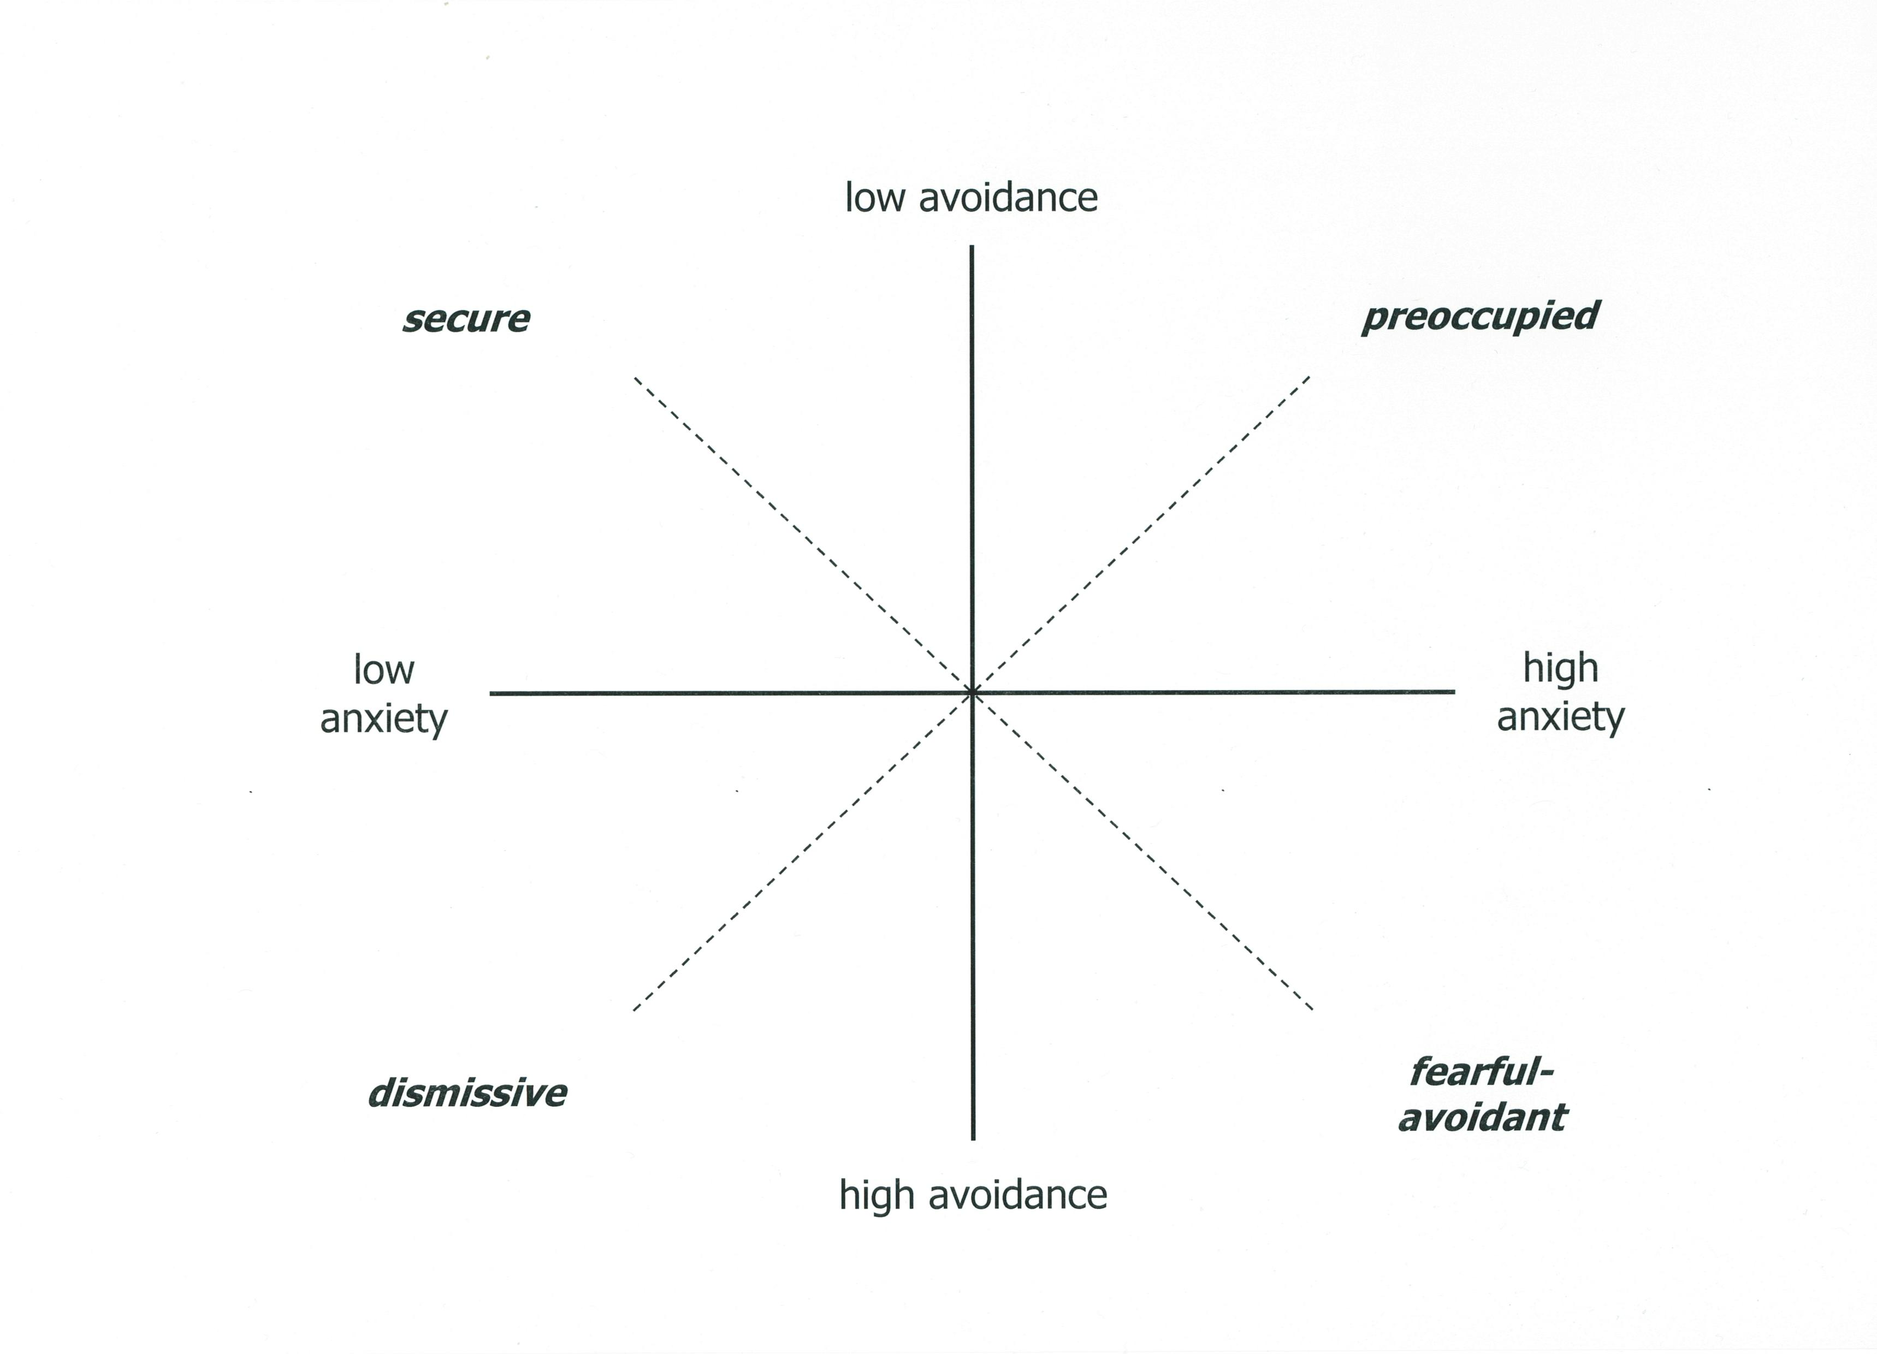

Further forms of attachment measure profilerated in the 1990's and as Fraley has described " ... research-ers and clinicians new to the field were drowning in a sea of self-report measures ... ". Happily in 1998, Brennan and colleagues "gathered all the self-report measures of adult attachment known at the time and administered the non-redundant items to 1,086 undergraduates. Factor analyses of the responses reveal-ed two major factors; the content of the items loading on these factors led Brennan and her colleagues to label them attachment-related anxiety and attachment-related avoidance." The Brennan paper was a breakthrough and she and her colleagues used their data to produce a new questionnaire, [Cont.]
the Experiences in Close Relationships (ECR) inventory. This 36 item questionnaire is made up of 18 statements about anxiety and 18 about avoidance. See Phil Shaver and Chris Fraley's excellent web-
page on Self-report measures of adult attachment for more details of the ECR and other questionnaires. In 2000, Fraley, Waller & Brennan re-analysed items from adult self-report measures and produced the Experiences in Close Relationships - Revised (ECR-R) inventory again assessing attachment-related anxiety (i.e., how much people are insecure vs. secure about the extent to which their partner's are available and responsive) and attachment-related avoidance (i.e., how much people are uncomfortable being close to others vs. secure depending on others). Fraley gives more background to the ECR-R at his Information on the ECR-R webpage. Here he also gives details of an online version of the questionnaire, but note only 16 of the 36 statements in the online version are actually the same as the standard ECR-R.

It makes excellent sense to use the ECR or the ECR-R as one's key assessment measure in clinical work Clicking on the Experiences in Close Relationships - Revised (ECR-R) inventory provides a downloadable MS Word version of the full standard questionnaire that I've put together. Clicking on the ECR-R Dimensions scoring chart provides a downloadable MS Powerpoint sheet allowing ECR-R scores to be graphically illustrated and monitored (or if you don't have access to Powerpoint, then here's a Word version). It takes approximately 10 minutes for someone to answer the ECR-R's 36 questions, and another 2 or 3 minutes to calculate average scores for their anxiety and avoidance. Happily, if one is filling in the inventory for more than one relationship (e.g. for both one's mother and one's partner, etc), it only takes about an extra 5 minutes to complete the ECR-R for each additional relationship assessed.
Be cautious though about over-glibly classifying oneself or others on these scales. Yes, we do tend to fall into particular styles in our close relationships. However it is clear that our styles are "dimensional" and nuanced not just blunt, general "categories". So, for example, I might typically have a secure attachment style with my partner, but I could at times slide into a temporary dismissive style (and noting this tendency might be very helpful). Our close relationship style can also evolve over time - to become more secure or less secure - depending on the relationship experiences we encounter (and co-create) in our lives. Attachment style also varies between our different close relationships. Assessing attachment can be very helpful, but be aware that styles are mixed, variable and individualized.

